**SEABORN:**

1. **IMPORTING LIBRARIES AND DATA:**

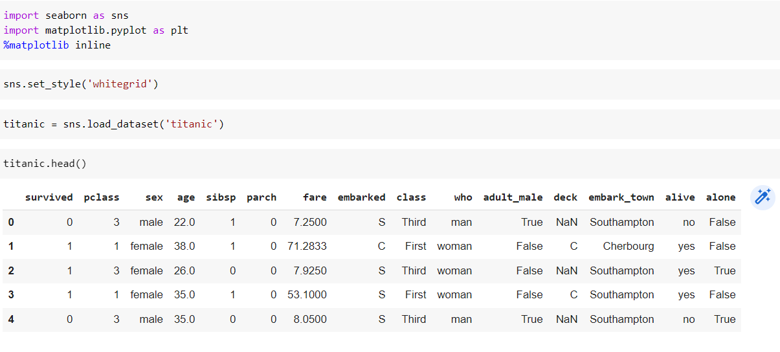

1. **JOINPLOT [FARE V/S AGE]:**

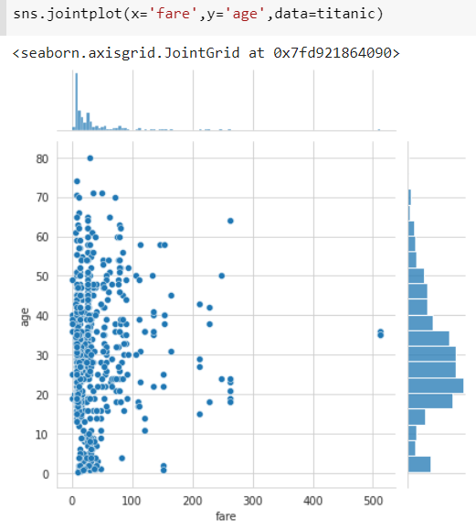

1. **DISPLOT:**

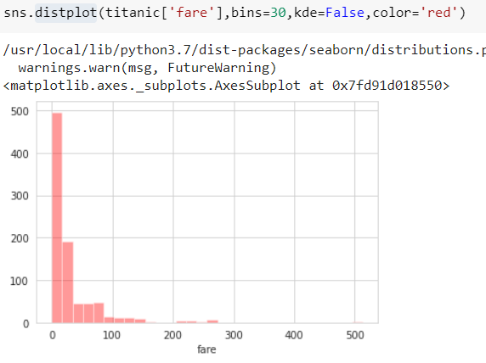

1. **BOXPLOT:**

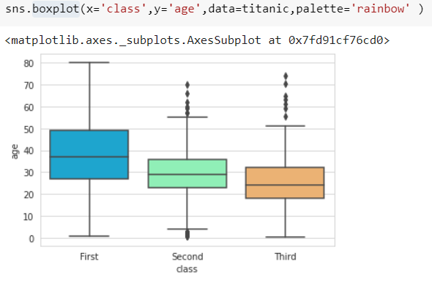

1. **SWARMPLOT [CLASS V/S AGE]:**

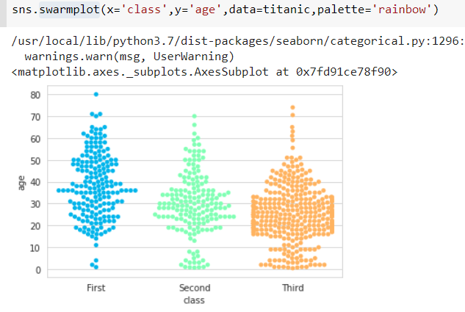

1. **COUNTPLOT:**

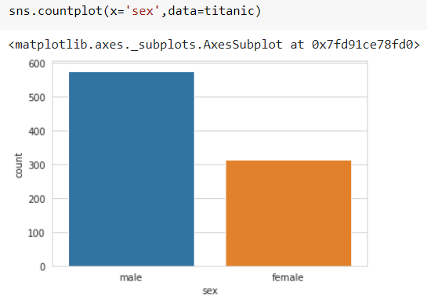

1. **HEATMAP:**

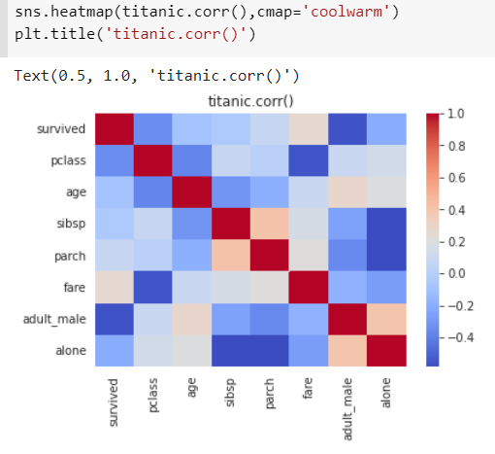

1. **FACEGRID:**

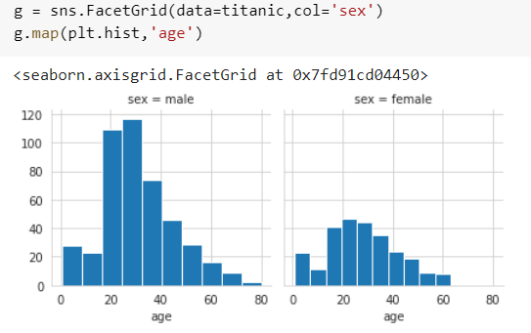

**CONCLUSION:**

#### From this practical, I have successfully learned about seaborn library in python.